Basic SQL Queries

Step 1:

Creating database school

Step 2:

Creating a table student in school database

Step 3: Using INSERT to add data

create table student(

name varchar(20),

class varchar(20),

address varchar(20),

email varchar(20))

insert into student (name, class, address, email) values ('Tom', '7a', ' address', 'tom@email.com');

insert into student (name, class, address, email) values ('Thomas', '7a', 'address', 'thomas@email.com');

insert into student (name, class, address, email) values ('Manuel', '7a', 'address', 'manuelm@email.com');

select * from student

step 4:Using SELECT to view the data

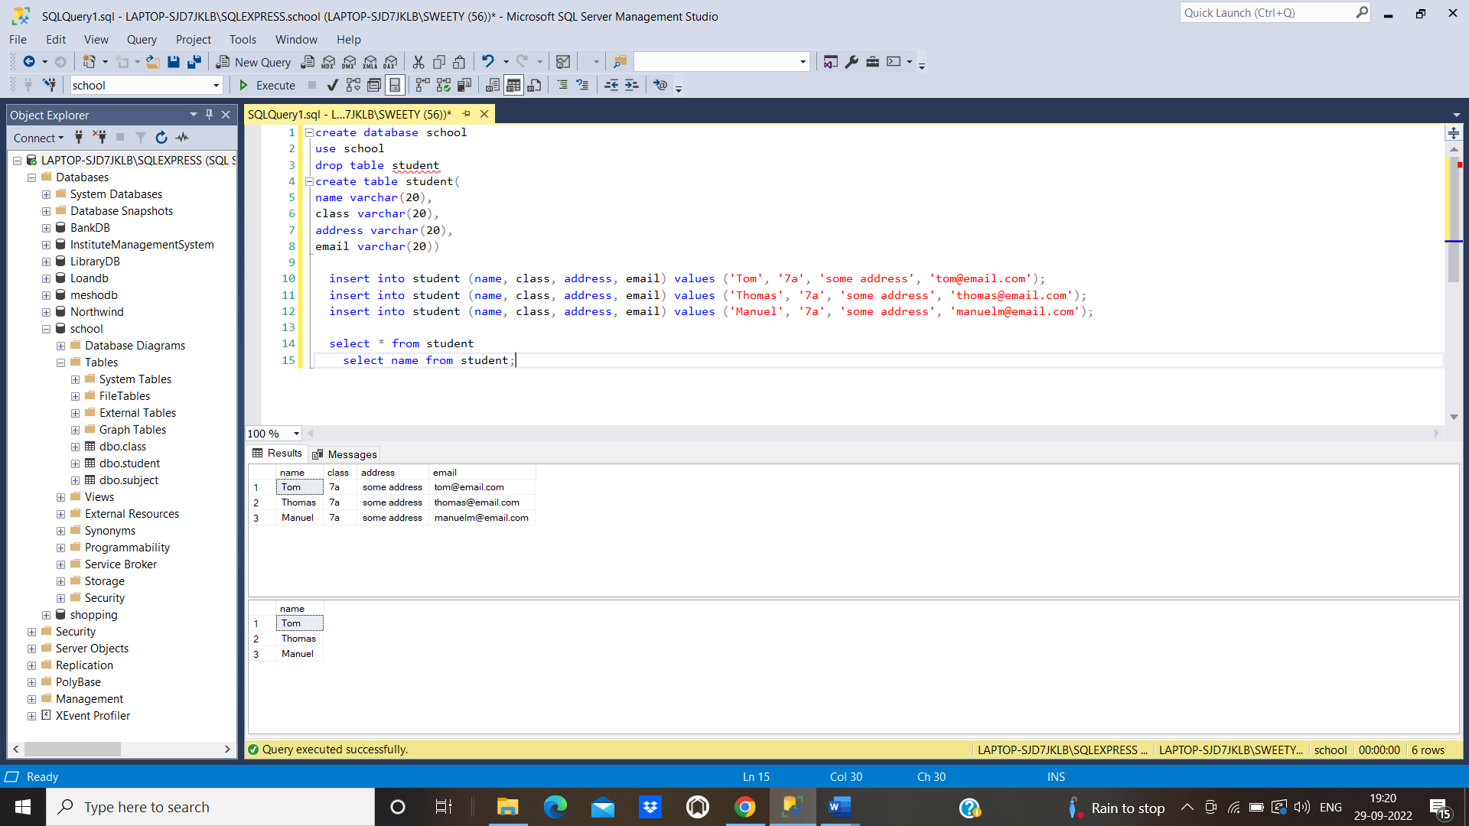

Step 5:using update to update data

**update student set class = '8a';**

**update student set name = 'Tom Clancy' where name = 'Tom'**

**STEP 6:** using delete to delete data

**delete from student where name = 'Tom Clancy'**

**delete from student**

**step 7:** Using filter and sorting for displaying data

**select * from student where name like 'm%';**

**select * from student where email = 'thomas@email.com' and class='8a';**

**select * from student order by name;**

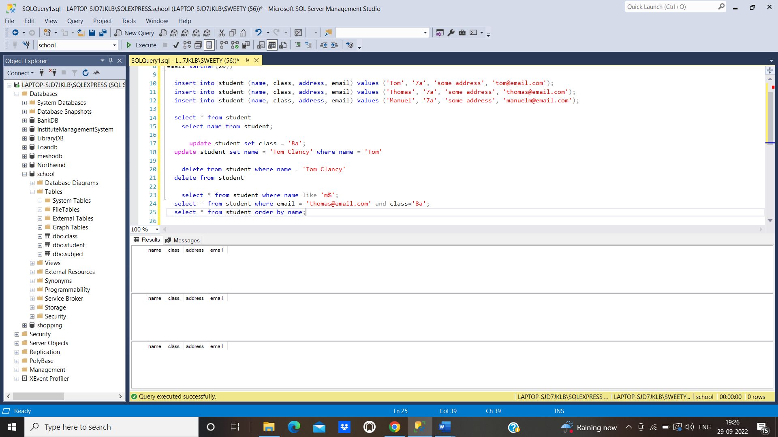

**Step 8:** Using variables in queries

**declare @namevalue as varchar(100)**

**set @namevalue = 'Mitchell'**

**use school1**

**select * from student where name = @namevalue**

**step 9:**

Pushing the code to your GitHub repository

* Open your command prompt and navigate to the folder where you have created your files.

**cd <folder path>**

* Initialize your repository using the following command:

**git init**

* Add all the files to your Git repository using the following command:

**git add .**

* Commit the changes using the following command:

**git commit . -m “Changes have been committed.”**

* Push the files to the folder you initially created using the following command:

**git push -u origin master**